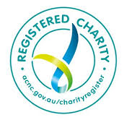
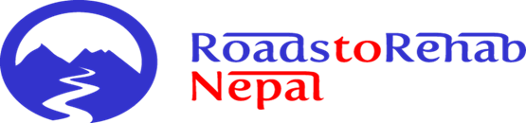

ROADS TO REHAB NEPAL ANNUAL REPORT 2020 - 2021
"I don't have any money to do this treatment. You are the only hope for me and my family. I have suffered a lot".
In just 4 months, NHEDF changed his life: “I will never forget this organisation. You give me a new life. I am so happy. I can work as before and provide for my family."
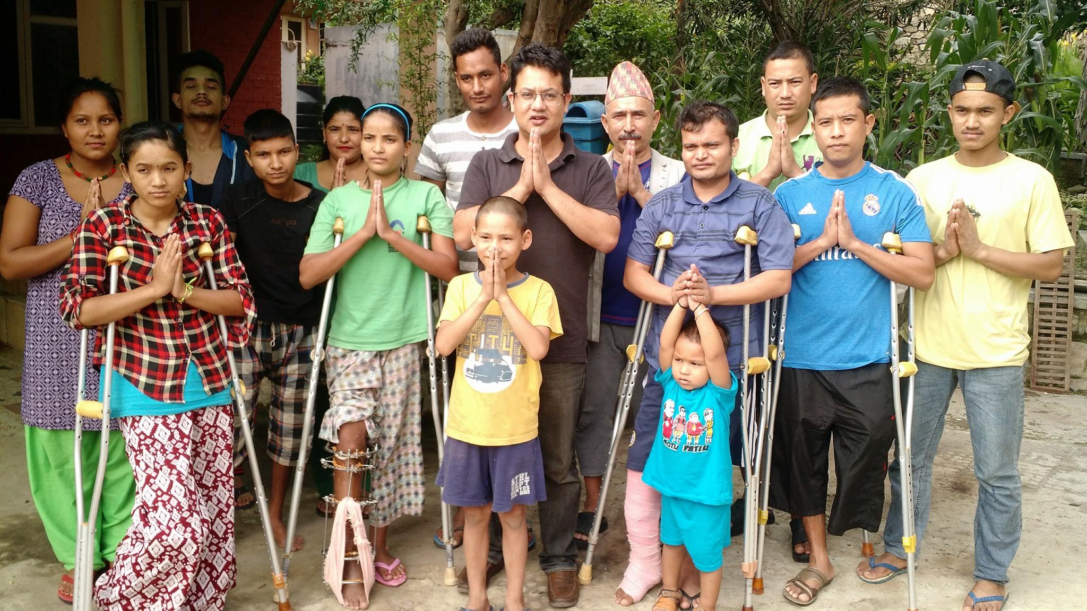
CONTENTS
About us – Our mission, what we do and how we do it
Trustee Report
Your impact and our achievements
Our Nurse and Physiotherapist Sponsorship Program
Our NHEDF project
The impact of COVID-19 on life at NHEDF’s Shelter
Annual Financial Report
Thank yous and acknowledgements
How you can help
Contact us
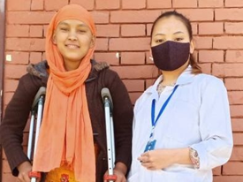
ABOUT US
Roads to Rehab Nepal is a non-profit organisation registered with the Australian Charities & Not-for-profits Commission (ACNC). We work in partnership with an organisation in Kathmandu called NHEDF (Nepal Healthcare Equipment Development Foundation). NHEDF was established in 2015 following the earthquake and we partnered with them in December 2016.
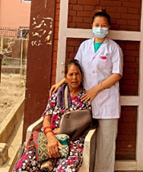
Our mission Many people in Nepal do not have access to medical care and rehabilitation services. Poverty is widespread. Like the World Health Organisation, we believe free health and medical care should be a universal human right.
What do we do? Together with our project partner, NHEDF, we improve health outcomes by funding and facilitating access to medical and surgical intervention, nursing care, physiotherapy and rehabilitation services for people who experience life changing illness or injury but cannot access these services due to poverty.
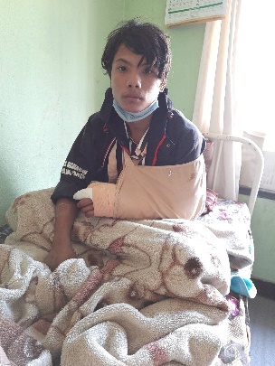
How do we do it? We rely solely on donations. We pay the wages of NHEDF’s three nurses and a physiotherapist. We fund as much as we can of NHEDF’s pharmacy bill which includes not only essential medications, but all medical, nursing, physiotherapy and occupational therapy equipment and supplies needed for patients at NHEDF's Shelter. We also cover the cost of surgery, medical and hospital expenses when required.
The amount of support we can give to NHEDF is determined by our donors and we would like to start our annual report by saying a huge thank you for your ongoing support and generosity.
TRUSTEE’S REPORT:
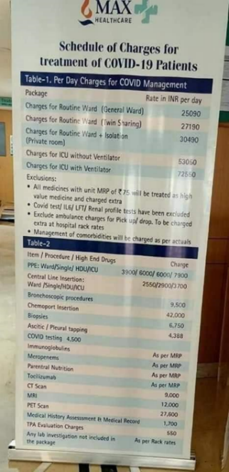
This year has been like no other but thanks to you, we have been able to continue our work, despite the many challenges that have faced both us and NHEDF with respect to the pandemic. We have been faced with a declining budget due to an inability to undertake our usual fundraising events; the end of our three-year funding commitment from the Rotary Club of Hall, and a reduction in donations as people face their own financial challenges brought about by the COVID-19 pandemic. We have also had to contend with disruptions to our operations and engage in a range of changes around how we fundraise.
To compound the situation, NHEDF has faced a significantly increased demand for its services as the number of people in Nepal experiencing financial distress has increased. Medical care became even more expensive as there was much profiteering around COVID. The pandemic resulted in many additional costs not just for NHEDF but for everyone in Nepal. Multiple lockdowns, restricted hospital access and cancelled surgeries have made the provision of medical care even more of a challenge than usual. It also became difficult to admit people to government hospitals resulting in increased reliance on the private sector.
This is the first time in many years that I have not been able to make an annual visit to Nepal, and I have been so concerned about friends, staff, patients and everyone at NHEDF. I am so proud of all NHEDF’s staff and volunteers who have done an amazing job of keeping COVID-19 out of the Shelter during a time when there were more than 8,000 cases a day in Nepal.
Thanks to you, we have continued to meet our commitments to NHEDF and have been able to cover the wages of three nurses and a physiotherapist; fund much of NHEDF's pharmacy bill; facilitate ongoing professional development for NHEDF's clinical staff; strengthen good governance and comply with all due diligence, governance and reporting obligations required by the ACNC and GlobalGiving.
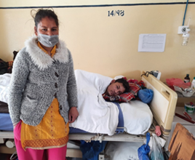
This financial year, due to the pandemic, many surgical cases were cancelled. Some of NHEDF's patients were operated on in a small window of opportunity between lockdowns whilst others had to return home. They will be recalled at some stage, but no one knows when. Thankfully, this year NHEDF has had wonderful support from other donors both within and outside Nepal to help with the cost of medical care. Consequently, we have not been required to fund surgical or hospital expenses.
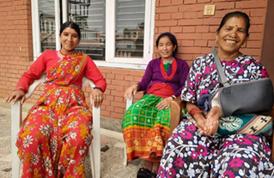
Sadly, the pandemic has meant we have been temporarily unable to support women with obstetric fistula. Travel restrictions, lockdowns, cancellation of elective and non-urgent surgery and the pressure on health facilities both in Kathmandu and throughout Nepal has meant many patients at NHEDF, including women with fistula, have missed out.
We hope that with the help of vaccinations and the ongoing work of all the amazing scientists around the world this pandemic will be turned into a common cold and life will return to normal.
We are all incredibly grateful for your support and look forward to hopefully a better year for everyone.
With best wishes,
Virginia Dixon
President, Roads to Rehab Nepal
YOUR IMPACT & OUR ACHIEVEMENTS
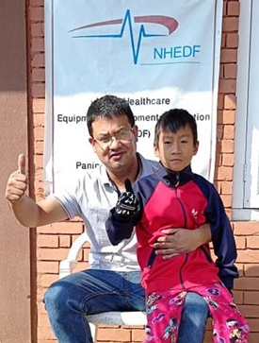
This year, because of you, 58 lives have been changed. Thanks to your generosity, these men, women and children have had access to the best surgical, medical, nursing care, physiotherapy and rehabilitation services possible and have been treated with kindness, compassion, dignity, safety and respect. This brings the total number of lives NHEDF has changed to 758.
This financial year has been challenging as we have been faced with a declining budget due to a number of factors. These include an inability to undertake our usual fundraising events; the end of our three-year funding commitment from the Rotary Club of Hall, and a reduction in donations as people face their own financial challenges brought about by the COVID-19 pandemic.

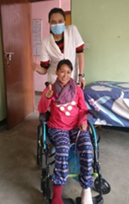
OUR NURSE AND PHYSIOTHERAPIST SPONSORSHIP PROGRAM
Integral to our commitment to improve the health of people who have experienced life changing illness or injury is our Nurse and Physiotherapist Sponsorship Programs. These fund the wages of NHEDF’s three nurses, Aashika, Lucky and Rajani, and physiotherapist, Anjeela.
NHEDF’s clinical staff continue to provide non-discriminatory, person centered, individually tailored, culturally appropriate nursing care and physiotherapy to all patients at NHEDF’s Shelter, regardless of their age, gender, ethnic group or religion. This is done in a socially responsible way, adhering to standards for practice, codes of conduct and codes of ethics which guide the delivery of care. Staff perform their duties in accordance with mutual obligations and registration standards, whilst striving for best practice.
OUR NHEDF PROJECT
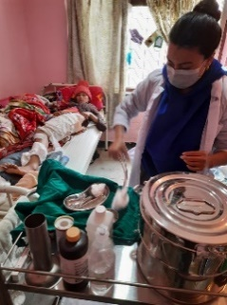
Without the support of NHEDF, many patients would have died or become disabled from the long-term consequences of lack of treatment. Many have enormous medical debts by the time they arrive at the Shelter, and some have said they would have taken their own lives if it were not for NHEDF.
Without NHEDF, the patients' physical, social, emotional, and psychological needs would simply not be met, and complex wounds would not heal. Without expert physiotherapy, many patients would be bedbound with all of the health consequences that entails and would experience loss of function and increased disability.
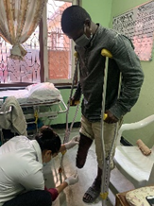
Part of our commitment to NHEDF is to promote sustainable development and one way we achieve this by supporting the ongoing education of NHEDF’s clinical staff. For NHEDF’s nurses, this has been facilitated through an online subscription donated by the nurse education company, Ausmed. Anjeela has been provided with access to the Australian Journal of Physiotherapy and has been receiving the monthly professional development updates from Orthosports, a large Orthopaedic practice in Sydney. We wish there was a physio version of Ausmed as NHEDF's nurses say it has been so useful, but we have not been able to find one. If you are aware of something similar let us know!
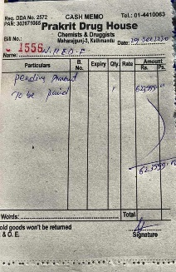
Thanks to your generosity, we have been able to fulfil our commitment to fund a large part of NHEDF's pharmacy bill. Prakit Drug House supplies the Shelter with essential medications, nursing and physiotherapy supplies, including PPE, oral and injectable medications, equipment such as intravenous cannulas, needles, wound dressing products, catheters, nasogastric tubes, mobility aids, OT aids like air mattresses and anything else that patients require.
Another of our commitments to NHEDF is to help strengthen its capacity for good governance. These activities are much easier to do in person, however regular communication with Director, Samrat, and NHEDF's clinical staff has meant we have been able to build on both patient and staff codes of conduct and further strengthen behaviors around appropriate social media. In addition to this, safeguarding and child protection practices and financial policies have been strengthened. This year, clinical staff have also taken on an active role within the Board.

NHEDF PROJECT & COVID-19:
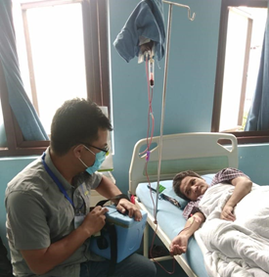
Samrat said: “During this pandemic we listen to our patients, and we plan their treatment in Kathmandu. It is hard to believe what they have gone through. One thing we make sure of is that their treatment will not stop. They are in the right place. We make sure we hold their hands and support each of them until their final treatment is completed. Although we have tough times we never stop working. We are proud that in every crisis our team worked selflessly with the same energy".
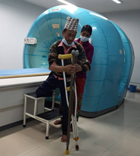
This year has had not only all its usual challenges for NHEDF but additional ones thanks to the pandemic. As always, NHEDF's Director, Samrat, continues to advocate for its patients and help them navigate their long road to rehabilitation through a medical system which has become even more complex since the onset of COVID-19.
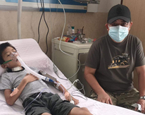
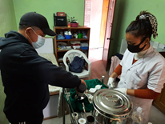
After the first wave, life at NHEDF ticked along, just as it always did with 16 patients and their caregivers. However, when Nepal went into lockdown, things changed. Staff were sometimes not allowed to work (we continued to pay their salaries). New patients or those requiring urgent surgery were not allowed to be admitted to the Shelter and existing patients were not allowed to be discharged. These patients were supported in hospital and then discharged directly home.
Throughout all lockdowns, those patients who remained at the Shelter continued to be cared for by their family members with staff working 12 hour shifts on alternate days to ensure less exposure to the virus. With only one staff member on at a time, Board Member, Devindra, became an excellent assistant in nursing!
The last three months of this financial year have been very frightening for everyone at NHEDF, as Nepal has experienced the worst of the pandemic with the inundation of hospitals with COVID patients. Like India, the country also ran out of oxygen. Also, the economic consequences of unemployment, combined with the impact the pandemic has had on many health services throughout the country has made for a higher and increasing demand for NHEDF’s services from many already vulnerable families.
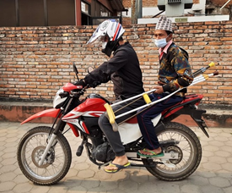
Samrat said about the situation in lockdown: “In normal days if there were any complications at our Shelter, we used to rush our patients to nearby hospitals. Many of our patients had follow-up appointments but due to the last lockdown they do not happen, and we have had to tackle everything by ourselves. Even the way we had to transport patients to hospital had to change”.
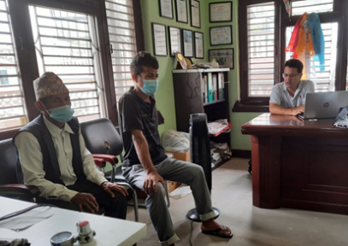
“Our nurses had to deal with things they would not normally have to do. We were afraid to send our patients to hospital as we were hearing lots of stories about COVID patients and so many people have died. We also had black fungus. Many hospitals and hospitals departments were sealed. We could not get patients there even if we wanted to. We kept hoping that the information we were receiving was not true. We don’t know how long this situation is going to last and how long we have to suffer from the consequences. It has been so difficult for so many”.
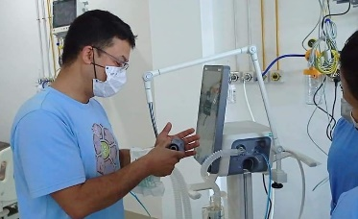
As the situation started to worsen, Samrat, as a biomedical engineer, was called on to educate hospital staff and help set up equipment in Intensive Care Units throughout the Kathmandu valley and beyond.
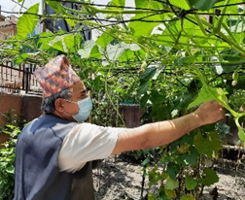
He was the first person at NHEDF during the recent wave to contract COVID-19. Board Member Devindra had had COVID previously, as had Staff Nurse Rajani. NHEDF's Treasurer was next to contract it and sadly passed away in early May when the pandemic was reaching its peak. Everyone managed to keep COVID out of the Shelter which was such an achievement especially as two patients had been having regular chemotherapy. We are so proud of them all.
On a positive note though, Lila, the father of long-term patient, Krishna Hari, has done an amazing job of tending the vegetable garden, and there were enough fresh organically grown vegetables to feed everyone for 3 months.
Also throughout this pandemic, NHEDF volunteers have done an amazing job of delivering humanitarian aid to ex-patients in remote communities.
ANNUAL FINANCIAL REPORT:
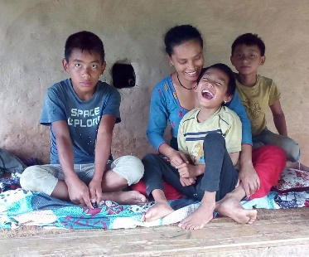
Our organisation is run solely by volunteers. Management Committee members continue to fund their own expenses, do not receive payment or benefit of any kind and regularly and generously donate many services. We rely completely on donations and our own fundraising efforts. The number of patients we can help and therefore the number of lives we can change is directly related to the amount of money we can raise.

NHEDF ACCOUNT
BANK BALANCE AS AT 30 JUNE 2020 14,693
RECEIPTS
Donations 22,069¹
Nurse & Physio Sponsorship 6,160²
Sale of Nepali handicrafts 605
Sale of woollen items 344
Raffle 300
Refund of overseas transfer fees 110³
Lorraine Lea fundraiser commission 71
TOTAL RECEIPTS 29,659

EXPENDITURE
Pharmacy 14,917
Clinical staff wages 9,519
Website maintenance 250
Domain name 445
Overseas transfer fees 180
TOTAL EXPENDITURE (25,311)
BANK BALANCE AS AT 30 JUNE 2021 19,041
FISTULA ACCOUNT⁴
BANK BALANCE AS AT 30 JUNE 2020 3,790
RECEIPTS NIL
EXPENDITURE NIL
BANK BALANCE AS AT 30 JUNE 2021 3,790

NOTES:

1. The major source of donations was the Global Giving Foundation ($12,369). These donations were from a number of individual donors plus matching donations from Global Giving itself. Other major donors were the Rotary Club of Hall ($5,000) and an individual donor ($3,000).
2. This sponsorship was donated specifically under Roads to Rehab’s nurse and physiotherapist sponsorship program.
3. St George Bank refunds Roads to Rehab’s overseas money transfer fees.
4. Fistula funds have not been able to be used due to the pandemic. They shall be held and used for the purpose for which they were intended as soon as fistula surgery recommences.

Paul Dixon

Treasurer, Roads to Rehab Nepal

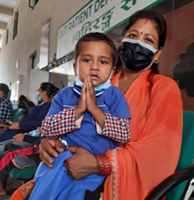
TO OUR DONORS, SPONSORS & SUPPORTERS - THANK YOU
We would like to emphasize that neither words nor photos can express the gratitude NHEDF’s patients, and their families have for your support, so on behalf of everyone involved, a million thanks for everything your generosity has enabled us to achieve over this financial year.
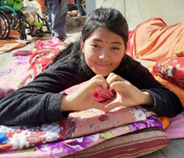
We gratefully acknowledge and thank our past and present donors, partners, sponsors and supporters both inside and outside Nepal, and all of you who live in many countries around the world.
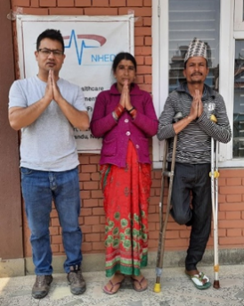
Our gratitude goes to everyone who plays a role in the success of both organisations; our wonderful Management Committee Members; NHEDF’s equally amazing Board members, clinical staff and volunteers; Grains of Life who continue to provide the Shelter with food on alternate weeks and Prakit Drug House. We cannot thank the Rotary Club of Hall enough for three years of support and more.
Special thanks go to Southside Physiotherapy Woden and Tuggeranong and all those individuals who contribute to our Nurse and Physiotherapist Sponsorship Programs year after year. Grateful thanks go to Duntroon Physiotherapy Department for donating many useful items which will make their way to Nepal when we can travel again and thank you again Ausmed for providing NHEDF’s nurses with a subscription to all their on-line learning resources. We appreciate the services of Flat Gecko Design in Canberra for taking care of our website for us. Without all your wonderful support, none of this would be possible.
HOW YOU CAN HELP
We look forward to another year, and your help in changing the lives of people in Nepal who have no one else to turn to and nowhere else to go. We know we cannot change the world, but we can change theirs.
We welcome all donations and regular contributions towards our Nurse and Physiotherapist sponsorship programs as they provide a level of financial security to us, NHEDF and its clinical staff, (and help our budgeting!) As we always say, a little bit of money goes a long way in Nepal. For example, $50 pays the wages of a nurse for a week. $70 is a week's wages for NHEDF's physiotherapist.
If you have any questions or would like more information about any aspect of our work, please visit our website http://www.roads-to-rehab-nepal.org or contact us on info@roads-to-rehab-nepal.org
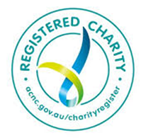
With best wishes and grateful thanks from all of us at Roads to Rehab Nepal, all past and present patients and everyone at NHEDF for your incredible support during this financial year.
Virginia Dixon
President Roads to Rehab Nepal

ABN: 14 196 214 542 ACT Fundraising Licence: L19001126
Tel: +61 417 675 258 Email: info@roads-to-rehab-nepal.org
Website: www.roads-to-rehab-nepal.org

